

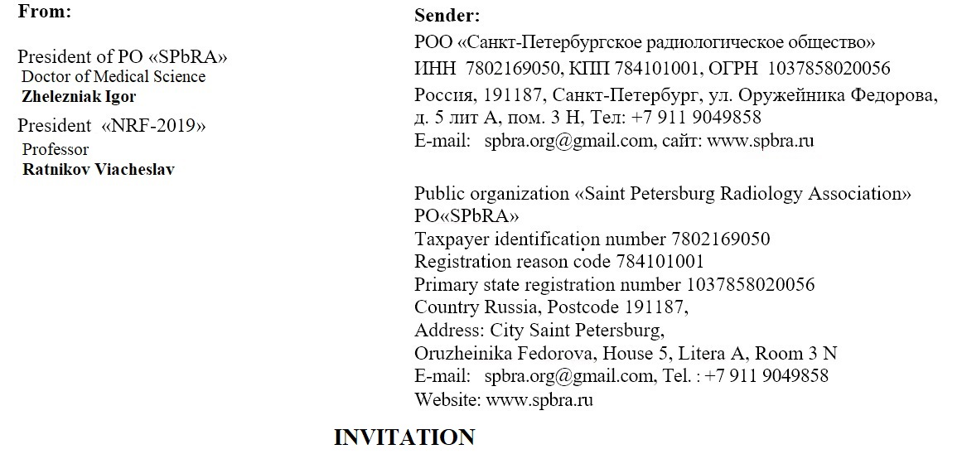

# Dear _________________________________________________!

